FACULTY PROFILE
Mr. Vidyadhar C. Kale
Assistant Professor
Department of Mechanical Engineering

Flat No.6,Vrishita Apt.  Gangapur road, Anandwali, Nashik  Mob: 9923896360  Email ID: vidyadhar.kale@ges-coengg.org | 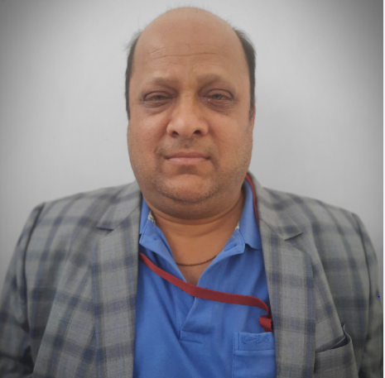
QUALIFICATION
- PhD(Pursuing)
- M.E.(Metallurgy)
- BE(Metallurgy)
TEACHING EXPERIENCE
- 13 Years as a Assistant Professor in R H Sapat COE, Nashik
- 1 Year as a Lecturer in College of Engineering, Pune
- 3 Years as a Lecturer in Bharti Vidyapeeth College of Engineering, Pune
INDUSTRIAL EXPERIENCE
- 16 Years
RESEARCH PUBLICATIONS
- Vidyadhar C. Kale, International Journal of Modern Trends in Engineering and Research, Volume 3, Year 2016, Pages 6
- Amitesh, Vidyadhar C. Kale, Aluminium Based Metal Matrix Composites for Aerospace Application: A Literature Review, IOSR Journal of Mechanical and Civil Engineering, Volume 12, Year 2015, Pages 6
- KALE VIDYADHAR CHANDRASHEKHAR, SAGAR DESHPANDE, Effect of Variance of geometric parameters and materials on poppet engine valve, International journal of researh, Volume 01, Year 2014, Pages 10
- Vidyadhar.C.Kale, Sagar .S. Deshpande, Design and Analysis of Poppet Engine Valve for Enhanced Mechanical Properties with Varied Geometric Parameters and Materials, International journal of engineering sciences & research technology (IJESRT), Volume 3, Year 2014, Pages 14
- Vidyadhar C. Kale, Roshan Dabhade, Design of Leaf Spring for Light commercial vehicle for enhanced Mechanical Properties and Reduced Weight To Improve Performance Over Life, JESRT, Volume 3, Year 2014, Pages 7
- Kale Vidyadhar Chandrashekhar, Dabhade Roshan, Review of Fatigue Analysis for Leaf Spring using Finite Element Methodology and Experimentation for Evaluating the Variation in Material and Geometry affecting the Performance over a Life, IJESRT, Volume 3, Year 2014, Pages 7
ADMINISTRATIVE WORK
Sr. No. | Post | Description
1. | Mentor Mentee In charge | Mentor Mentee scheme In charge at the departmental level

UNIVERSITY RESPONSIBILTITES
Sr. No. | Post | Duties
1. | Member | NA
2. | Subject Expert | NA
3. | Member | NA
4. | Subject Chairman, | NA
5. | Examiners  (External and Internal) | Practical and Theory subjects-Engineering Metallurgy
6. | Senior Supervisor (External and Internal) | Worked as as a External Senior Supervisor for SPPU examination

FDP/WORKSHOP/WEBINAR/SEMINAR ATTENDED
- Paticipated in CE & QIP workshop on Analysis of Modern Manufacturing Processes organized by IIT Bombay (February 20-24,2012)
- Attended ISTE approved STTP on Recent trends in Material Science and Energy Engineering organized by Konkan Gyanpeeth College of Engineering, Karjat, Raigad
- Attended National Seminar on Emerging Technologies in Micro & Nano Manufacturing (June 12-14, 2012)
ACHIEVEMENTS
Masters degree from Queens University, Canada
B.A. Economics from Brock University, Canada
M.M.S from Pune University

Mr.Vidyadhar C.Kale

