FACULTY PROFILE
Mr. Ajinkya Kishor Salve
Assistant Professor
Department of Mechanical Engineering

A/Y/8,Nandan Garden Society,  Pagare mala,Upnagar, Nashik  Mob: 8805361595  Email ID: ajinkya.salve@ges-coengg.org | 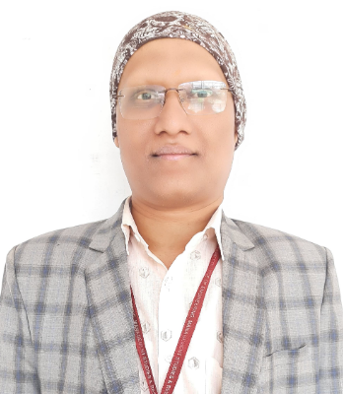
QUALIFICATION
- PhD(Pursuing)
- M.Tech(CAD-CAM-CAE)
- BE(Mechanical)
TEACHING EXPERIENCE
- 9 Years as a Assistant Professor in R H Sapat COE, Nashik
- 1 Year as a Lecturer in JMCTs Polytechnic, Nashik
RESEARCH PUBLICATIONS
- Ajinkya K. Salve ,Sudhindra N. Jalwadi, “Implementation of Cohesive Zone inABAQUS to Investigate Fracture Problems”, National Conference for EngineeringPost Graduate Students, NConPG 2015, ISBN-13:978-1512094169, 1st June 2015,Sakharale,pg60-66.
- Pooja Deshmukh,Ajinkya K. Salve“Material Optimizationand Static Analysis of Centrifugal Pump Impeller Using FEA”,International Journal of Trending Research and Development,ISSN:2394-9333,Volume 8 Issue2.March-April 2021
- Ashwini Chaudhary, Dr.P.B.Nehe, Ajinkya Salve “Machine learning Classification algorithms for prediction of surface finish of Flatwork Ironing Machine.”International Journal of Advance Research in Science and Engineering,ISSN:2319-8354,Volume No.10,IssueNo.5,May2021
- Ashwini Chaudhary,Dr.P.B.Nehe, Ajinkya Salve“K-means,Neural Network Clustering and Optimization of Flat work ironing machine.”29th World Conference on Applied Science, Engineering and Technology(WCASET-2020) organized by Institute for Engineering Research and Publication(14thOctober2020)
- R.V.Rao, Ajinkya K. Salve, Parameters optimization of selected manufacturing processes, AEOTIT conference, 28th -30th September 2023.

ADMINISTRATIVE WORK
Sr. No. | Post | Description
1. | Training and Placement Coordinator | Handling Training and Placement related activities at the departmental level.

UNIVERSITY RESPONSIBILTITES
Sr. No. | Post | Duties
1. | Member | NA
2. | Subject Expert | NA
3. | Member | NA
4. | Subject Chairman, | NA
5. | Examiners  (External and Internal) | Practical and Theory subjects-Numerical & Statistical Methods, Artificial Intelligence and Data Analytics Laboratory.
6. | Senior Supervisor (External and Internal) | Worked as as a External Senior Supervisor for SPPU examination

FDP/WORKSHOP/WEBINAR/SEMINAR ATTENDED
- Participated in Online Faculty Development FDP on "Advances in Manufacturing"from 4th January to 8th January 2021 organised by Sardar Vallabhbhai National Institute of Technology,Surat
- Completed Short Term Training Programme through ICT Mode on “CAD/CAM” from 27th April to 21st May 2020 organized by National Institute of Technical Teachers Training and Research,Kolkata
- Attended the online workshop on “Machine Learning for Data Science using Python” from 16th to 29th October 2023 organized by National Institute of Technology, Warangal.
ACHIEVEMENTS
- Worked as a Faculty Coordinator for SUPRA (Super Racing) SAEINDIA is a
national-level engineering student competition where teams design and fabricate a
Formula- style vehicle as per the design standards of SAE International.

Mr.Ajinkya K.Salve

