**FACULTY PROFILE**

**Mr.Dawange Satish Vijay**

**Assistant Professor**

**Department of Mechanical Engineering**

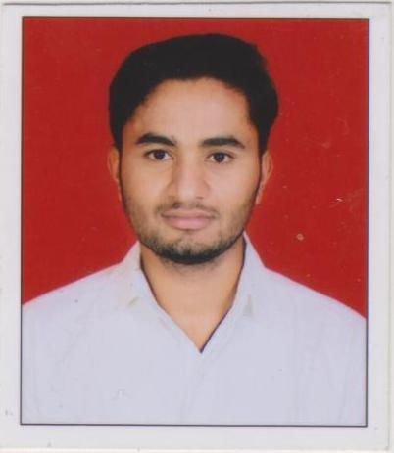

| 5, Jaishiv Dhara Row Houses,  Manakar Mala Makhmalabad, Nashik -03  Mob: 7775893057  Email ID: satish.dawange@ges-coengg.org |  |
| --- | --- |

**QUALIFICATION**

* ME( Mechanical Design)
* BE ( Mechanical)

**TEACHING EXPERIENCE**

* Current experience

Gokhale Education’s Society’s R.H.Sapat College of Engineering and Research, Management Center, Nashik

* Past experience

Let G.N.Sapakal College of Engineering, Nashik

**INDUSTRY EXPERIENCE**

* Atlas CopCo,Satpur Nashik
* HNG Glass Sinnar Nashik

**Paper Publication**

Review Paper on Vibration analysis of Diesel Engine and Condition Monitoring.

**ADMINISTRATIVE WORK**

| Sr. No. | Post | Description |
| --- | --- | --- |
| 1. | Timetable In charge | Preparation of a Timetable as per academic load. |
| 2. | Class Coordinator | Responsible for smooth conduction of the class activities of the TE mechanical class. |
| 3 | Member in Admission Committee | Performed the allotted activity as per the requirement in admission work |
| 4 | Member of NACC Criteria 7 | Responsible for performing the activity which are required in NACC criteria 7. |
| 5 | Member of Cultural Committee in Resonance | Carried out the given task successfully given by the Coordinator of the cultural Committee. |

**UNIVERSITY RESPONSIBILTITES**

| Sr. No. | Post | Duties |
| --- | --- | --- |
| 1. | TE CAP( Paper Checking) | Assessment of Theory Exam |
| 2. | Member | Paper Setting for the Subject of TE Mechanical Engineering |
| 3. | Examiners  (External and Internal) | Practical and oral exams for TE Mechanical Engineering |
| 4. | Senior Supervisor (External)  Invigilator | Theory exams  Supervision duties during University Exams |

**FDP/WORKSHOP/WEBINAR/SEMINAR ATTENDED**

1. Two Days FDP on GD&T by AMT skill Enhancement Institute, Nashik from 12th Feb 2024 to 13th Feb 2024.
2. AICTE Training and Learning (ATAL) Academy Faculty Development Program on Exploring Perspectives of AI & ML in Mechanical Engineering at K. K. WAGH INSTITUTE OF ENGINEERING EDUCATION & RESEARCH from 27/11/2023 to 02/12/2023.
3. 6 Days Faculty Development Program on Advanced Manufacturing from 12th June to 17th June 2023 at the AICTE IDEA Lab at at K. K. WAGH INSTITUTE OF ENGINEERING EDUCATION & RESEARCH, Nashik
4. One Week FDP On Recent Trends in HVAC in association with ISHRE and ASHRE pune chapter from 26th to 30th December 2023 at MMCOE Karvenagar Pune.

**ACHIEVEMENTS**

1. Worked as a Faculty Advisor for the Team Participated in the SAE BAJA Competition.
2. Has Contributed in the Problem Solving Based on CAE analysis of Clutch plate for the Mahindra SONA Ltd,Nashik.

Mr. Dawange Satish Vijay