FACULTY PROFILE
Mr.Tarle Ravindra A.
Assistant Professor
Department of Mechanical Engineering

Flat No.07, Woodland Apartment,  Behind Saint Peter School,  Near Shivkripa Sweets,  Vrindavan Nagar, Nashik-422003 | 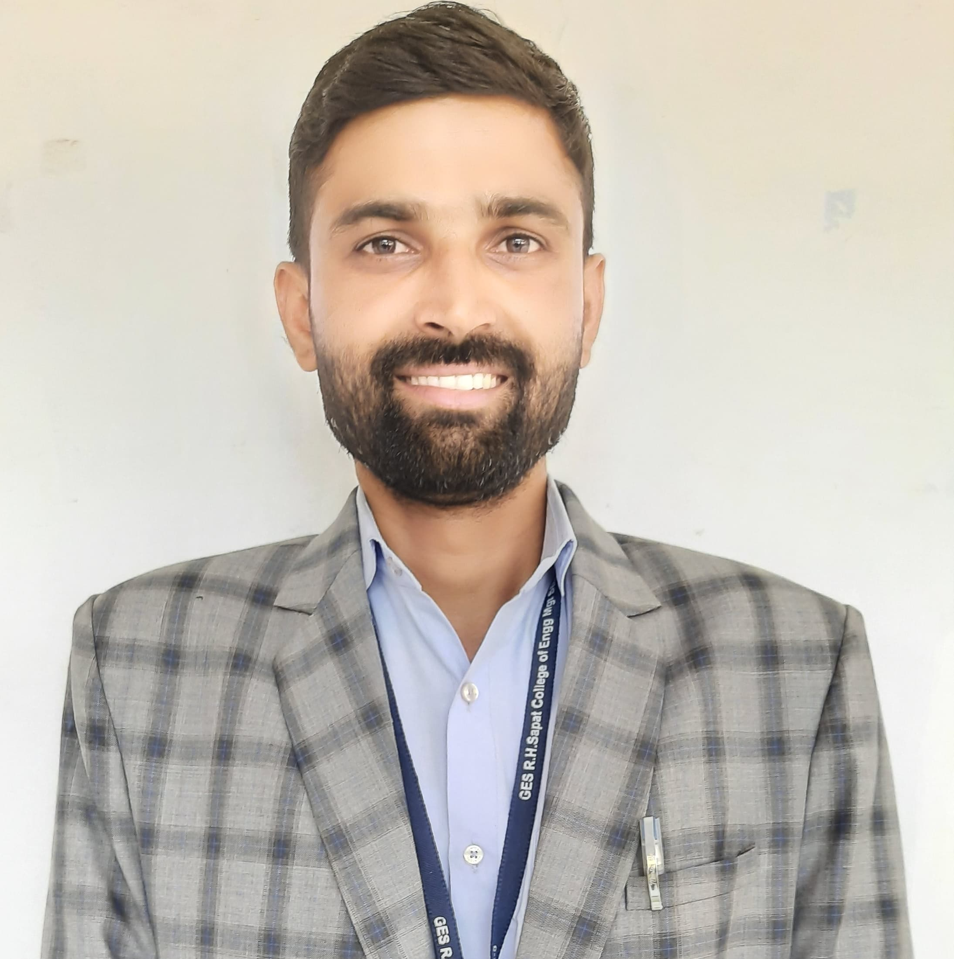
QUALIFICATION
- ME (Design Engineering)
- BE ( Mechanical)
TEACHING EXPERIENCE
- Current experience
Gokhale Education Society’s R.H.Sapat College of Engineering, Management Studies & research, Nashik-422005.
INDUSTRY EXPERIENCE
- KSB Pumps Ltd., Nashik

Paper Publication
A Paper on Vibration analysis of Ball Bearing.
ADMINISTRATIVE WORK
Sr. No. | Post | Description
1. | ISO Coordinator | Preparation of a Timetable as per academic load.
2. | Class Coordinator | Responsible for smooth conduction of the class activities of the FE class.
3 | Member in Admission Committee | Performed the allotted activity as per the requirement in admission work
4 | Member of NACC Criteria 2 | Responsible for performing the activity which are required in NACC criteria 2.
5 | Member of Cultural Committee in Resonance | Carried out the given task successfully given by the Coordinator of the cultural Committee.

UNIVERSITY RESPONSIBILTITES
Sr. No. | Post | Duties
1. | FE/TE/BE CAP( Paper Checking) | Assessment of Theory Exam
2. | Examiners  (External and Internal) | Practical and oral exams for TE Mechanical Engineering
3. | Examiners  (External and Internal) | Practical and oral exams for TE Mechanical Engineering
4. | Invigilator | Supervision duties during University Exams

FDP/WORKSHOP/WEBINAR/SEMINAR ATTENDED
- AICTE Training and Learning (ATAL) Academy Faculty Development Program on Exploring Perspectives of AI & ML in Mechanical Engineering at K. K. WAGH INSTITUTE OF ENGINEERING EDUCATION & RESEARCH from 27/11/2023 to 02/12/2023.
- Six Days Faculty Development Program on Advanced Manufacturing from 12th June to 17th June 2023 at the AICTE IDEA Lab at at K. K. WAGH INSTITUTE OF ENGINEERING EDUCATION & RESEARCH, Nashik
ACHIEVEMENTS
- Worked as a Faculty Advisor for the Team Participated in SAEISS E Bike Design Competition and Won first Prize, also won Best faculty advisor award in the event held 2022.
- Worked as a Faculty Advisor for the Team Participated in SIEP E Bike Design Competition and Won first Prize in the event held 2023.

Mr. Tarle Ravindra A.

